**DAILY ONLINE ACTIVITIES SUMMARY**

|  |  |  |  |  |  |  |  |  |
| --- | --- | --- | --- | --- | --- | --- | --- | --- |
| **Date:** | 22/05/2020 | | | | | **Name:** | D Richard Franklin | |
| **Sem & Sec** | Fourth SEM section A | | | | | **USN:** | 4AL18CS020 | |
| **Online Test Summary** | | | | | | | | |
| **Subject** | | Operating system | | | | | | |
| **Max. Marks** | | 30 | | **Score** | | | 24 | |
| **Certification Course Summary** | | | | | | | | |
| **Course** | Complete Python Bootcamp : Go from zero to hero in Python 3 | | | | | | | |
| **Certificate Provider** | | | Udemy | | **Duration** | | | 1 Hour 30 minutes |
| **Coding Challenges** | | | | | | | | |
| **Problem Statement:** 1. Stack operation using SLL  2. Round robin type of process scheduling | | | | | | | | |
| **Status:** Completed | | | | | | | | |
| **Uploaded the report in Github** | | | | | YES | | | |
| **If yes Repository name** | | | | | <https://github.com/richard3658/lockdown-coding> | | | |
| **Uploaded the report in slack** | | | | | YES | | | |

**Online Test Details:**

The online test was from module 1 which was about the introduction to operating systems, system structures, different operating system services and process management. There were 30 questions and the duration was 40 minutes. The questions were optimal and were easy. The score that I got in the test is 24/30.

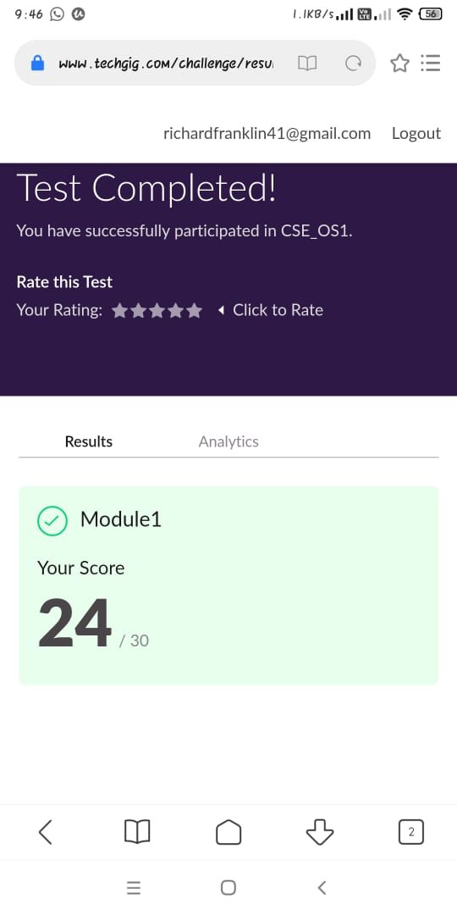

**Certification Course Details:**

**Name of the course**: Complete Python Bootcamp: Go from zero to hero in Python 3

**Certificate Provider**: Udemy

This course has 19 sections and the total duration is 24 hours.

In the fifth day I went through the section of the course that explained about object oriented programming and how it can be used while programming in python.

**Snapshot:**

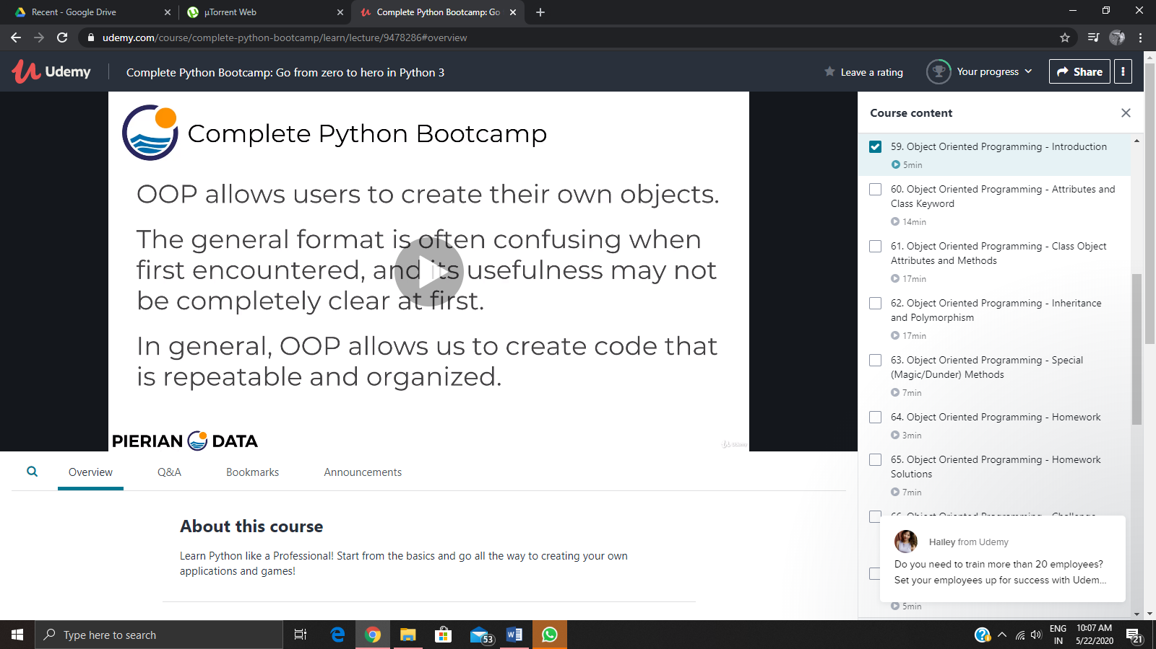

**Online Coding Details:**

Problem 1: (using C language) Do the basic operations on a stack where stack is implemented using singly linked list

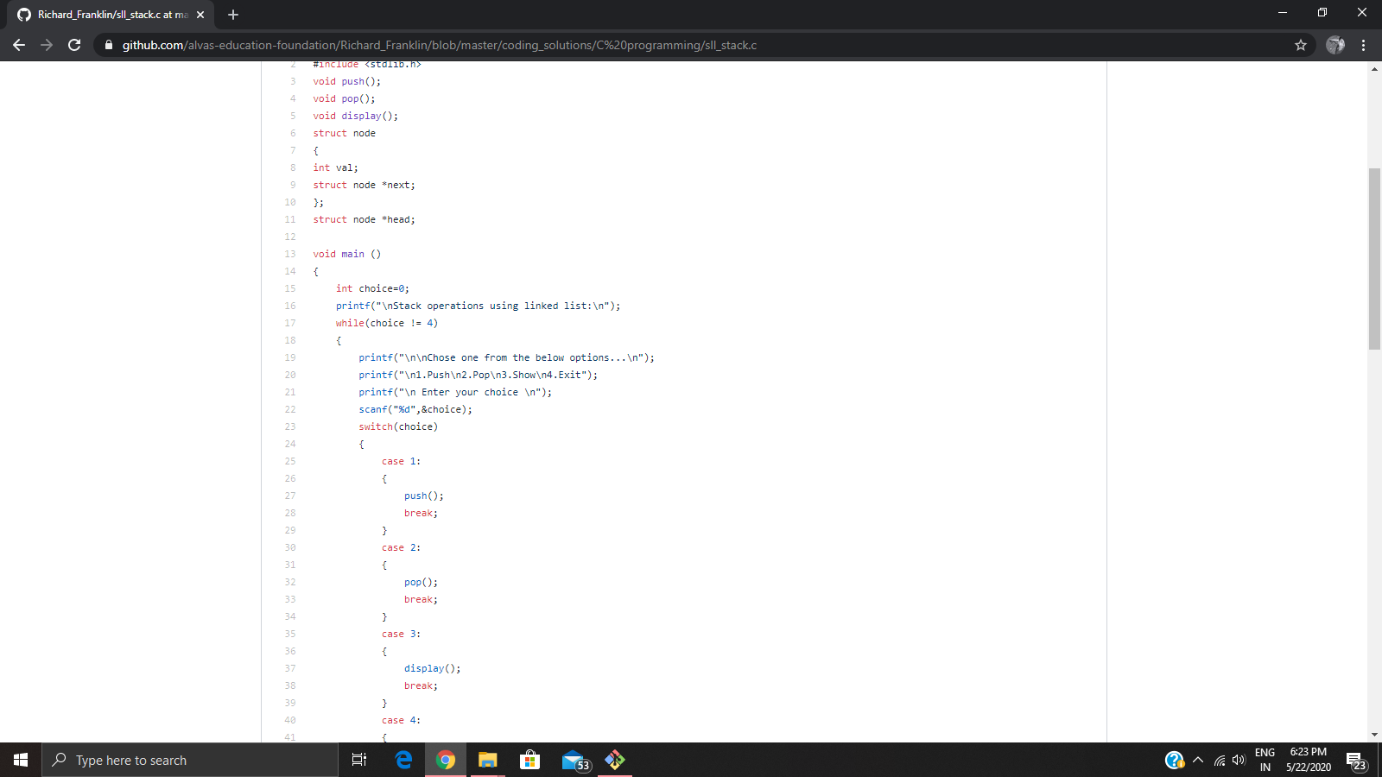

Problem 2: (Using C) Perform round robin type of process scheduling

